ssh -i devopspractice.pem ubuntu@3.91.134.194

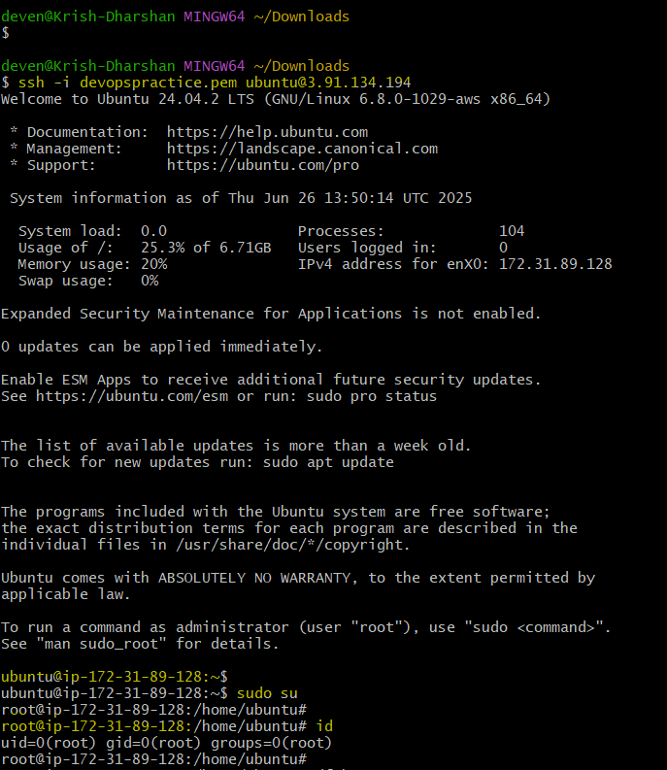

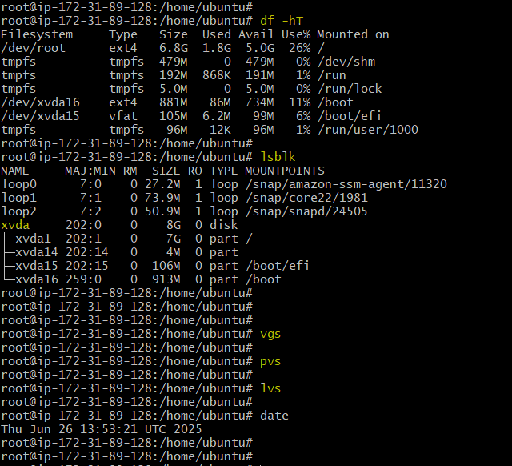

Create and EBS volume in the availability zone of the EC2 instance.

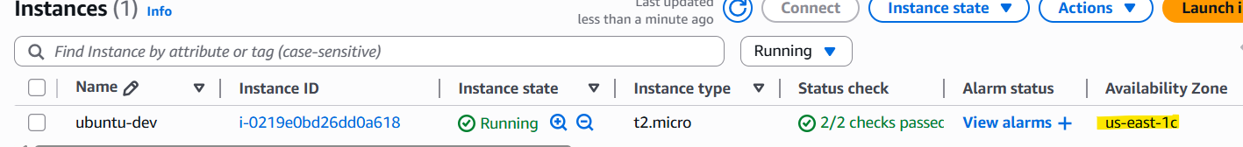

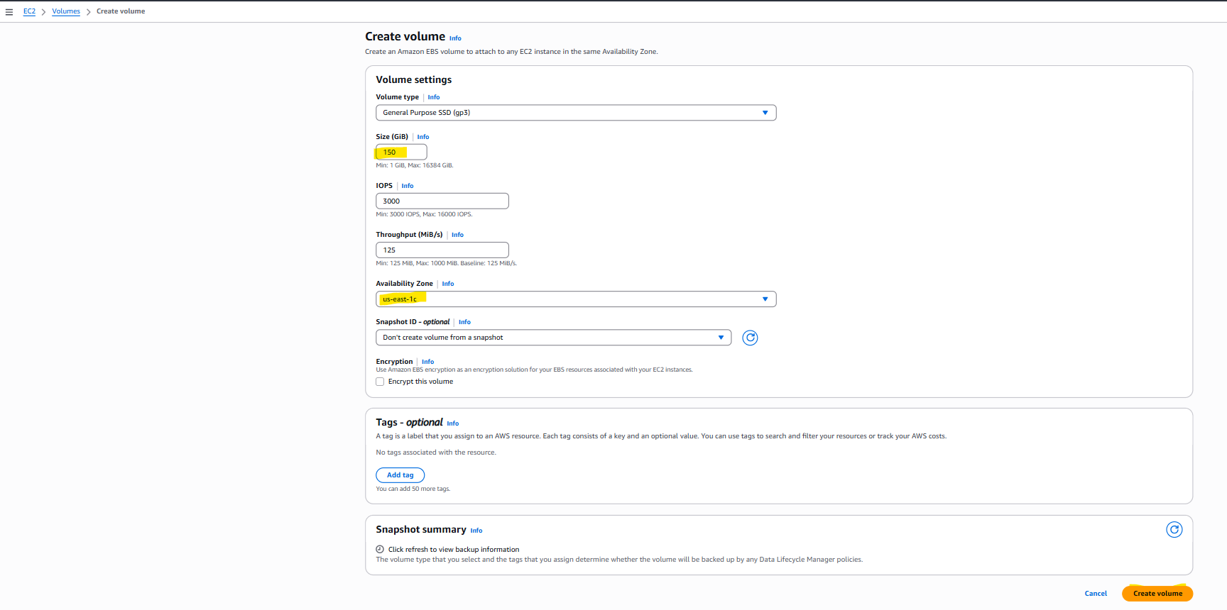

Attach the EBS volume to EC2 instance.

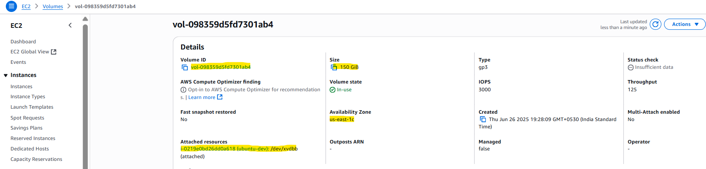

Now the new attached volume of 150GB will be visible on the server.

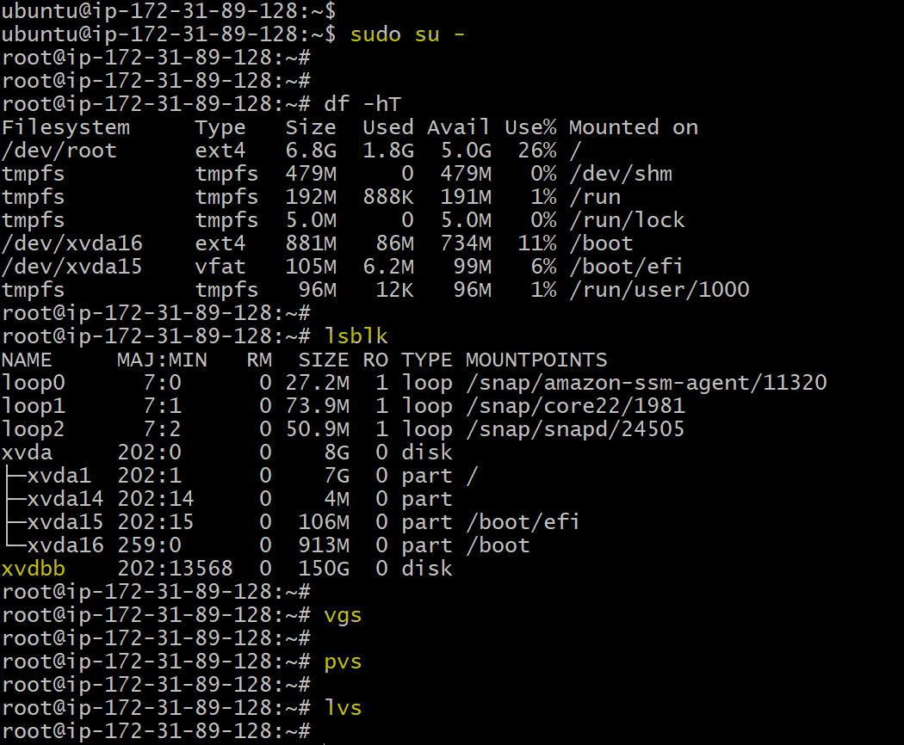

Tasks to be done.

* Create 4 partitions on drive/disk **/dev/xvdbb**

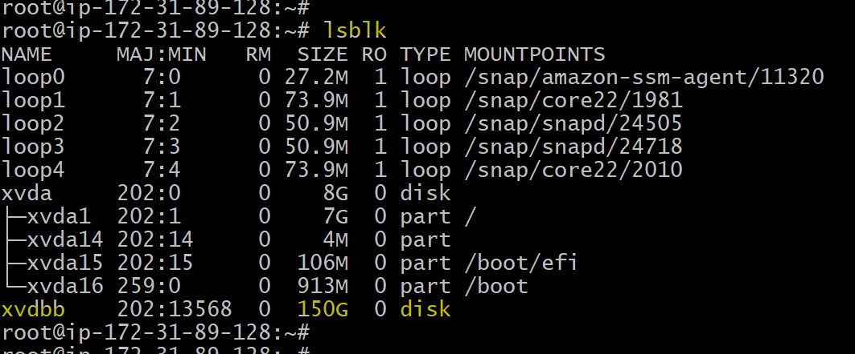

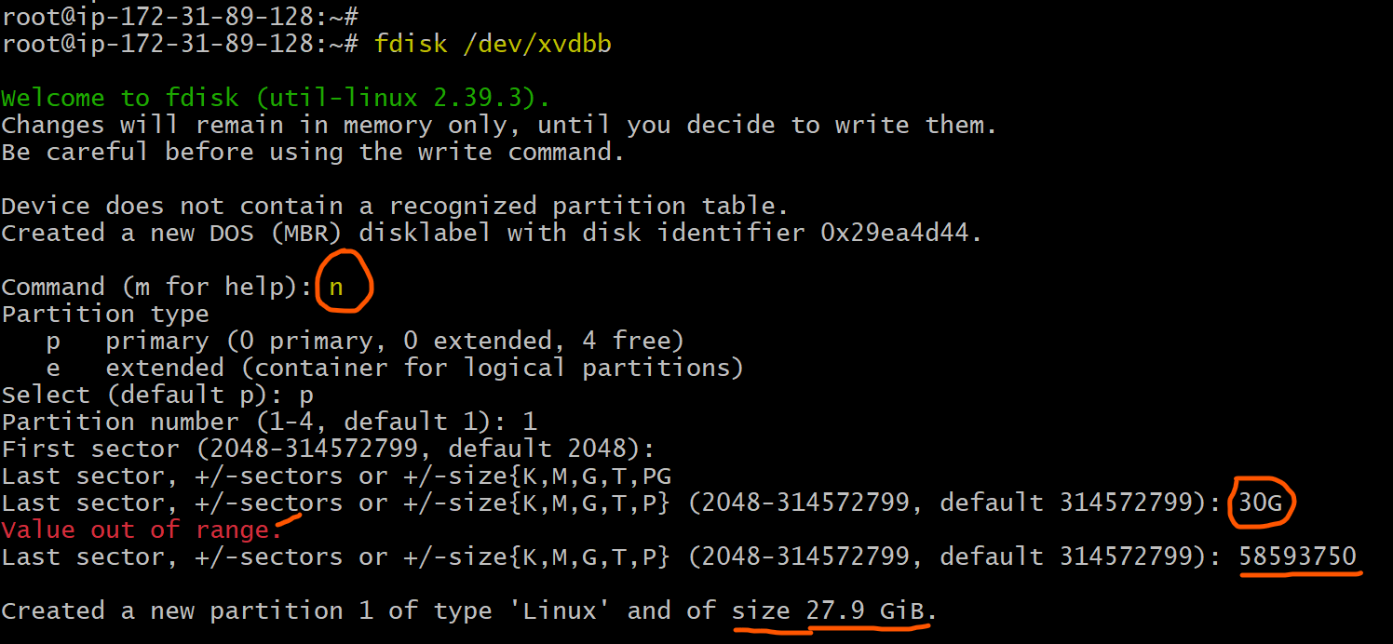

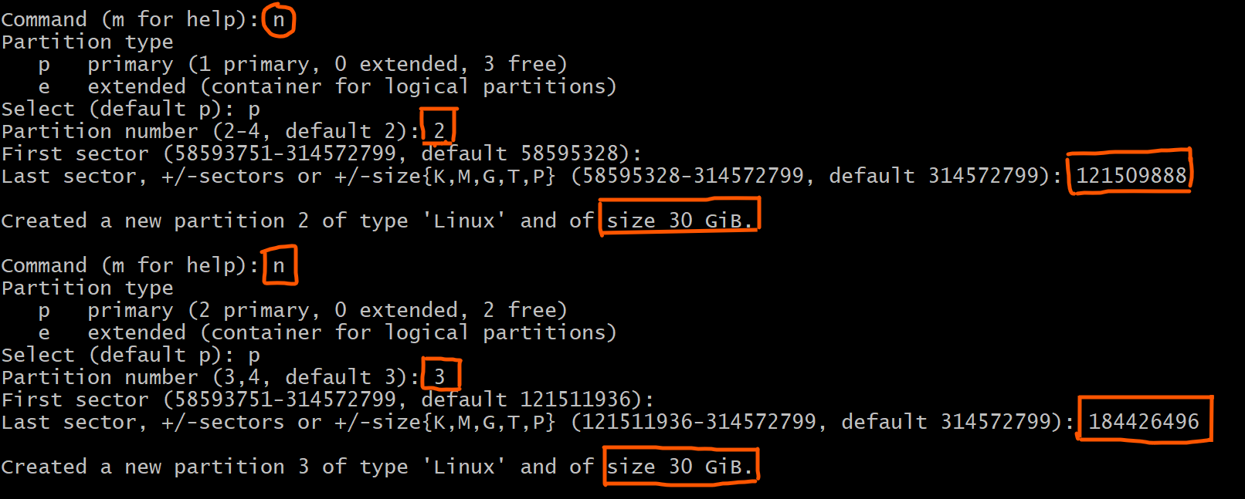

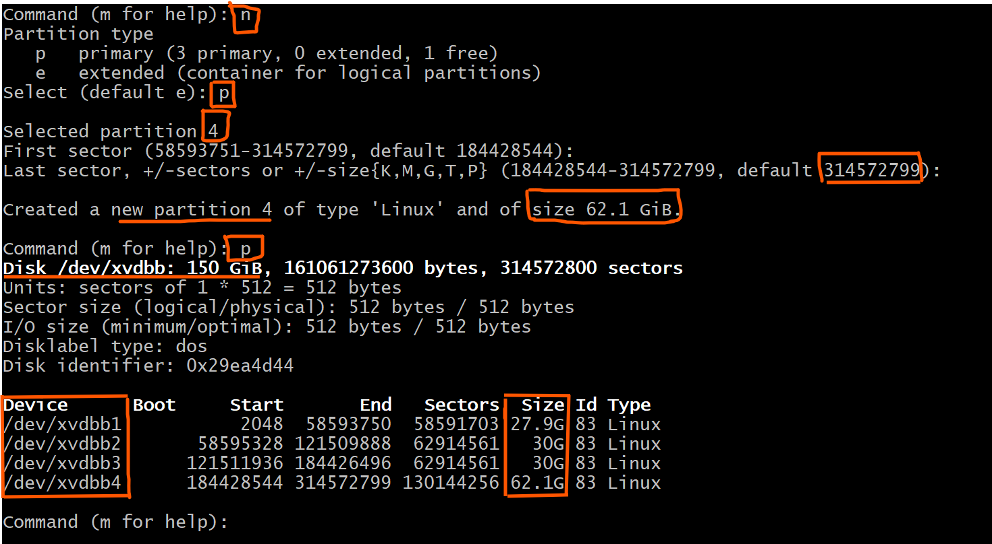

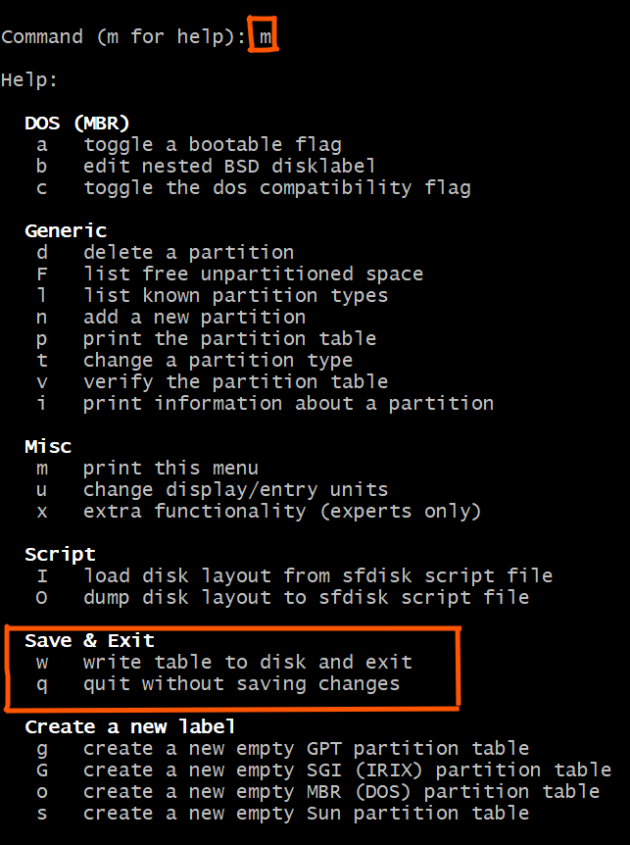

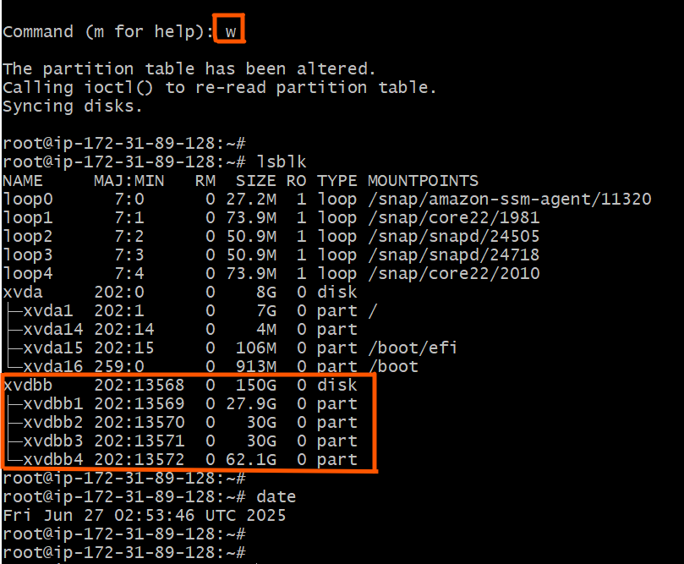

* Create Physical Volumes on the 4 partitions created.

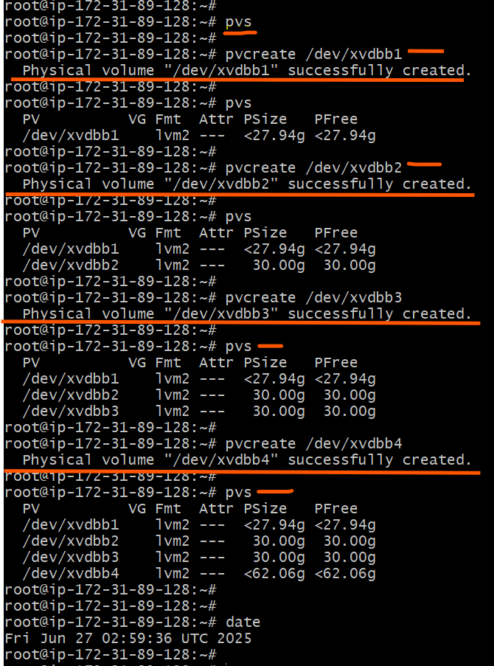

* Create a volume group with one physical volume initially

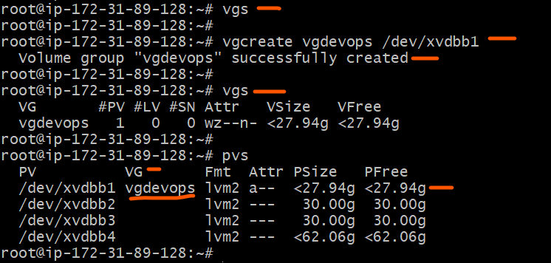

* Create a logical volume

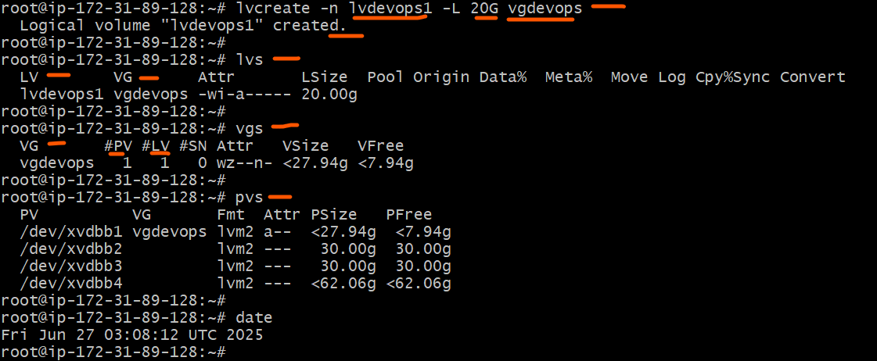

* Create file system on the logical volume.

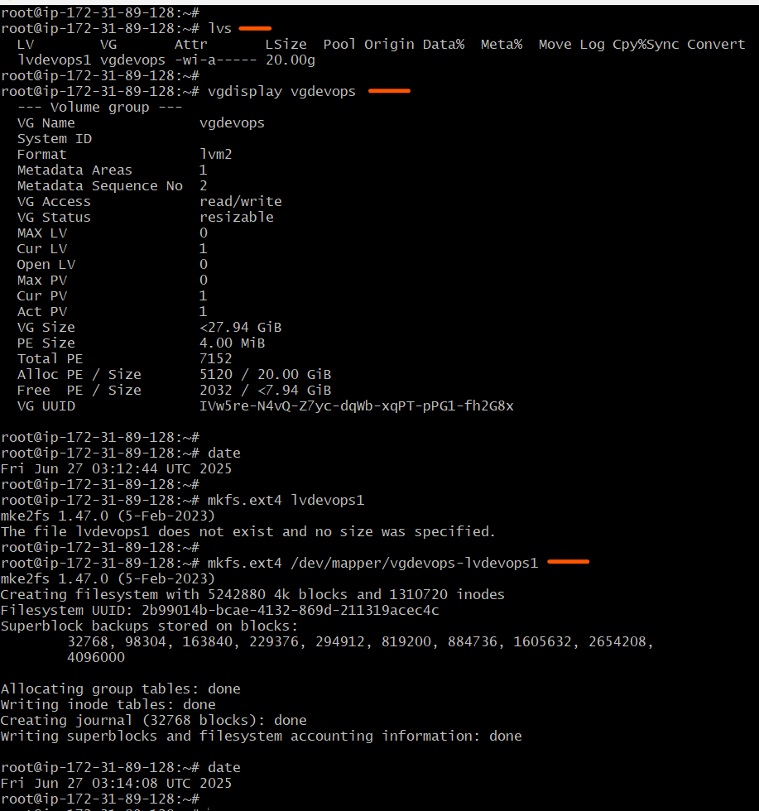

* Create a mount point
* Mount the LVM filesystem.
* Check df -h output.

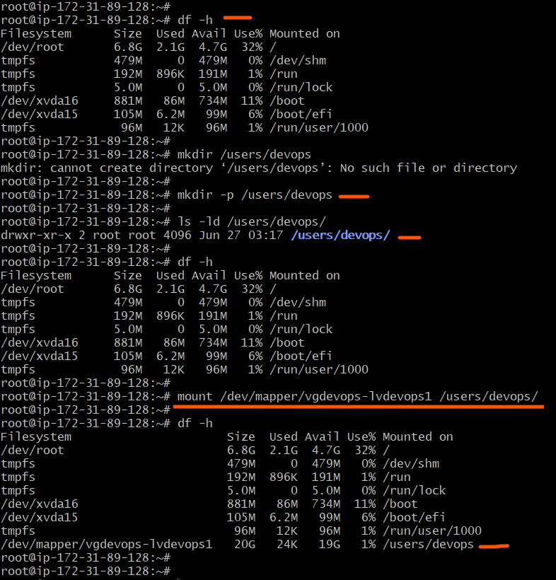

* Reboot the server

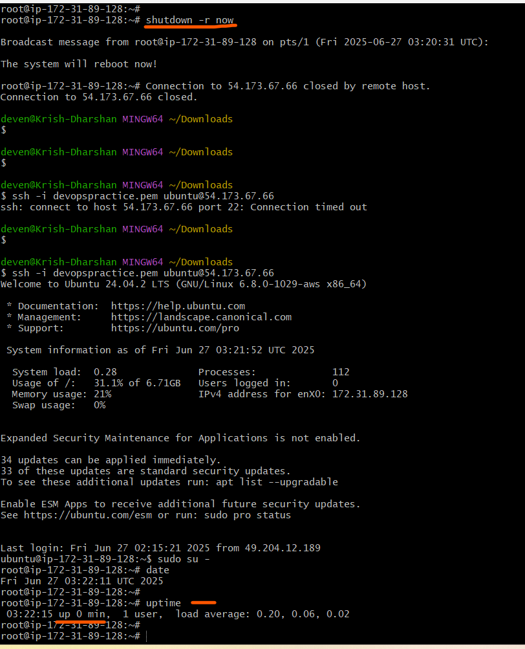

* Check df -h output and validate why lvm filesystem is not shown.

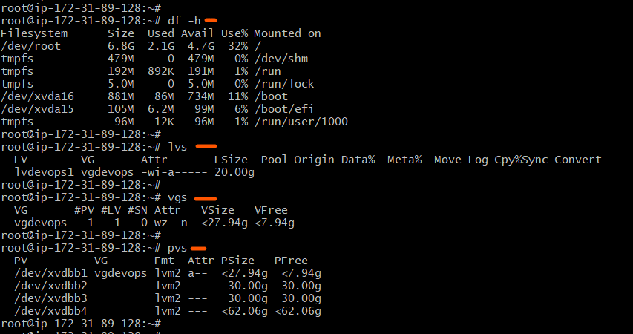

* Make Lvm filesystem persistent. Reboot the server.

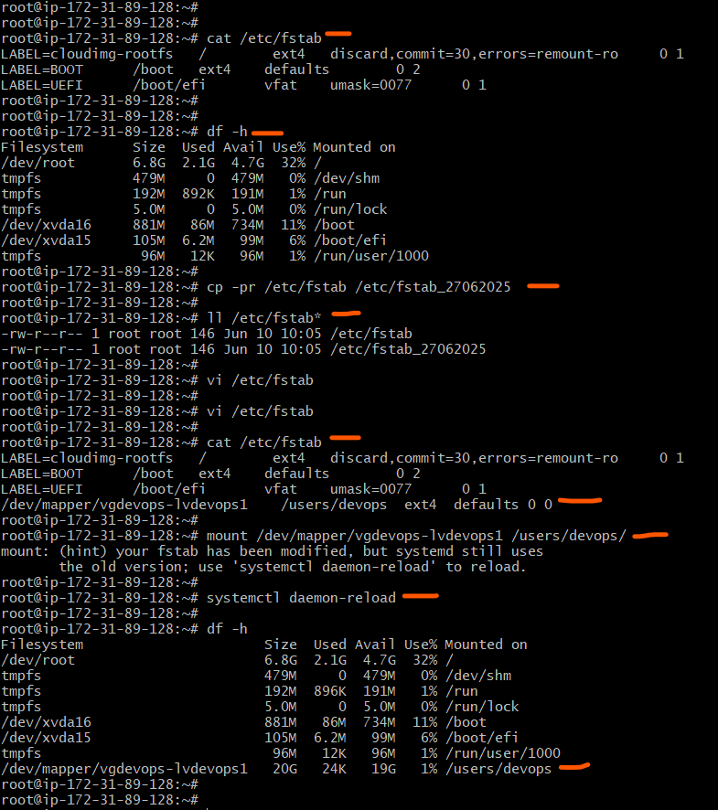

* Validate df -h output.

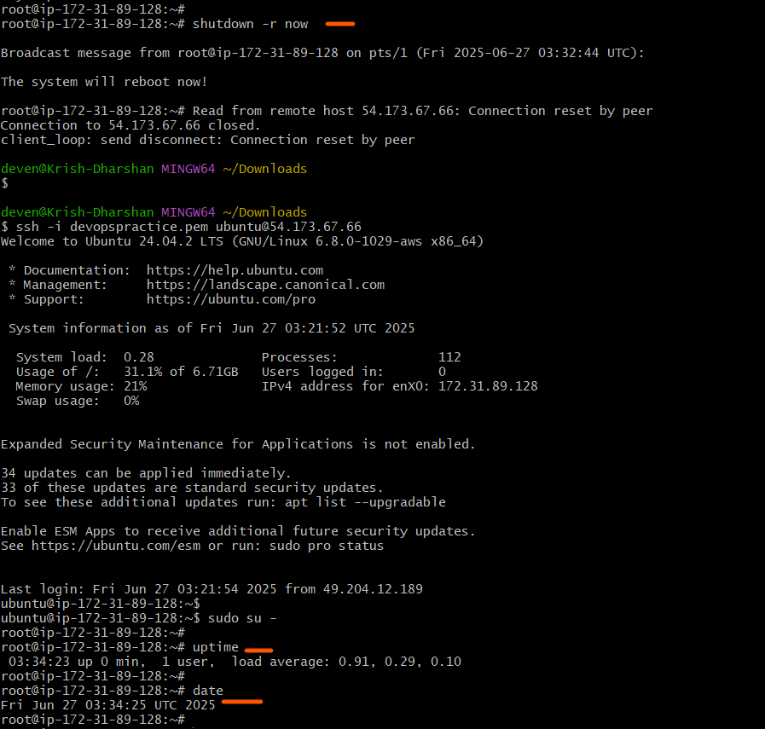

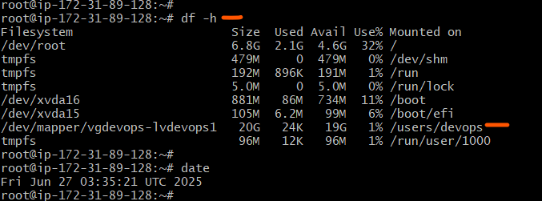

* Extend the filesystem size about 2 GB from available free space in Volume group.
* Resize the filesystem.

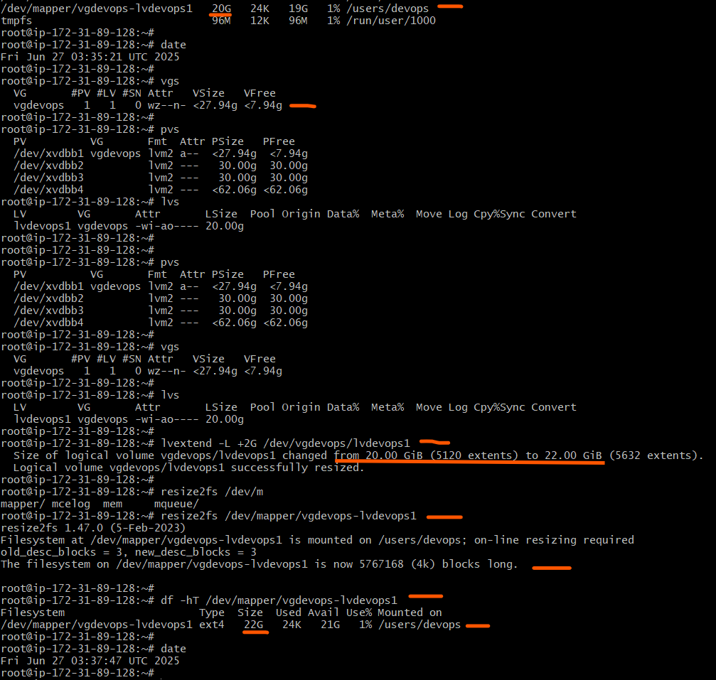

* Extend the filesystem with entire available free space in Volume group.

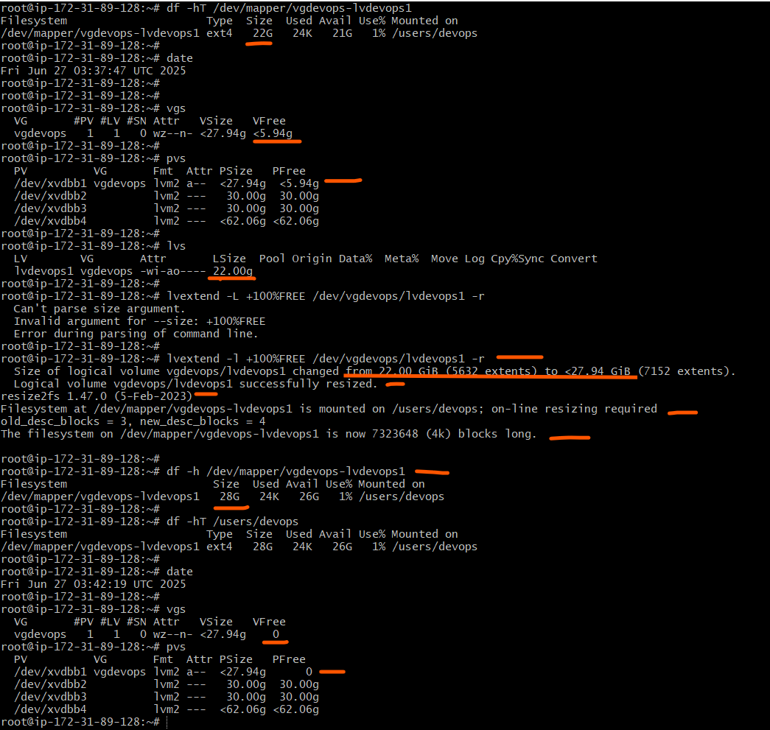

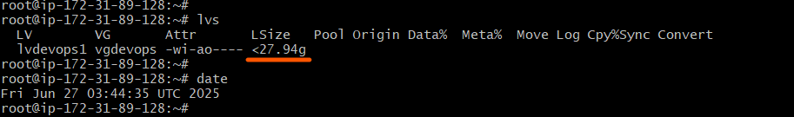

* Extend the file system size about 20 GB à Not possible as no space in vgdevops
* Extend Volume group à Extend filesystem and resize

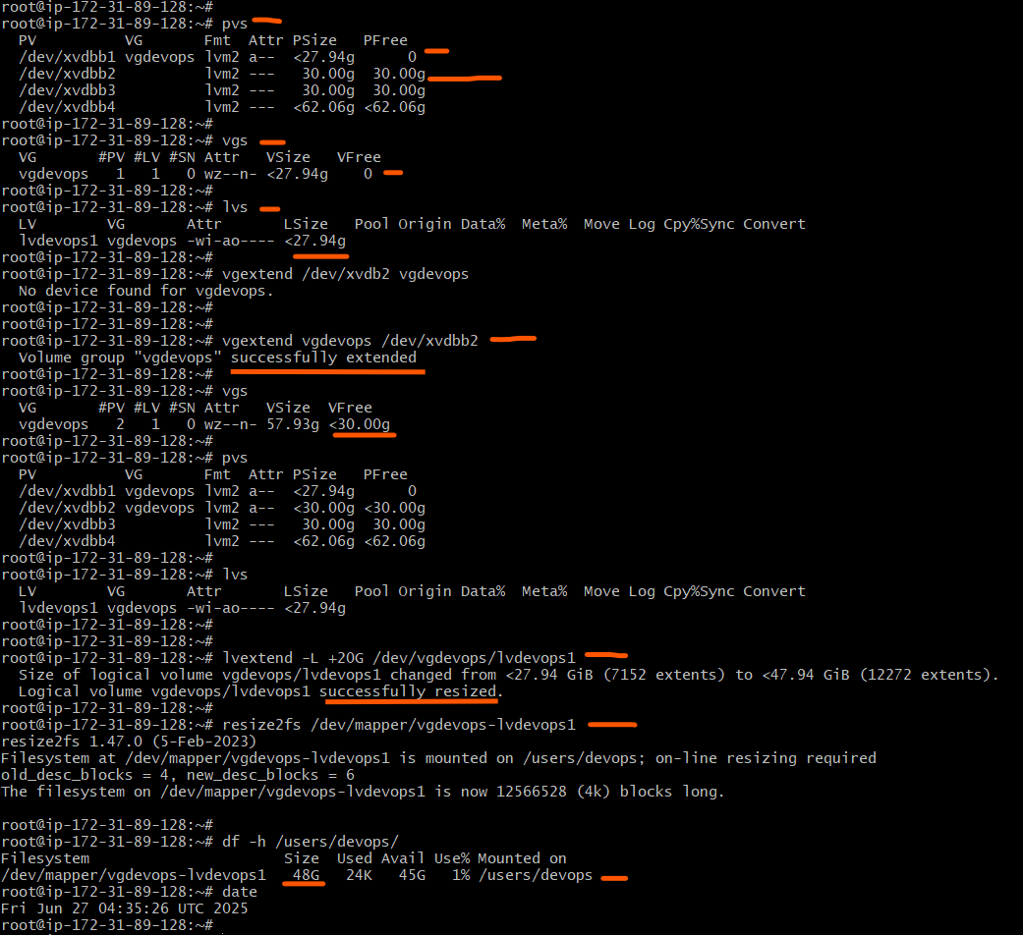

* Create new lvm with available free space in Volume group and create file system and mount it as persistent.

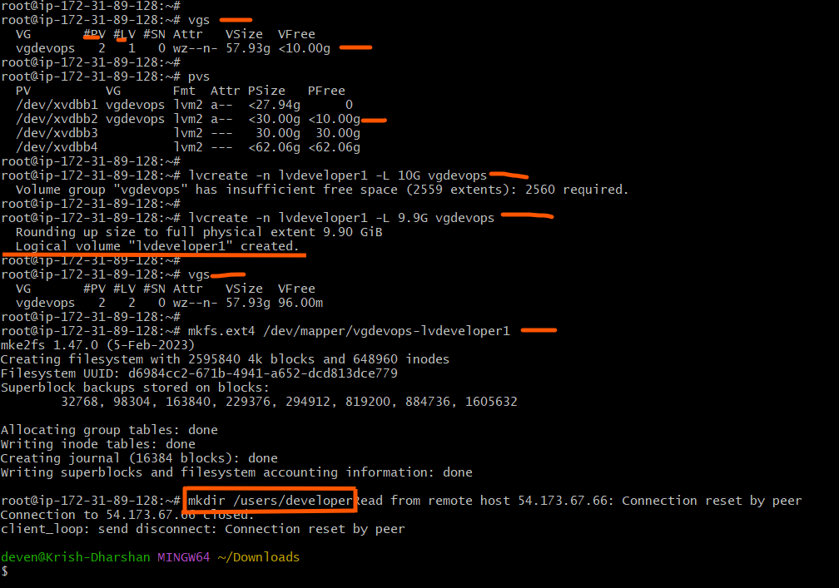

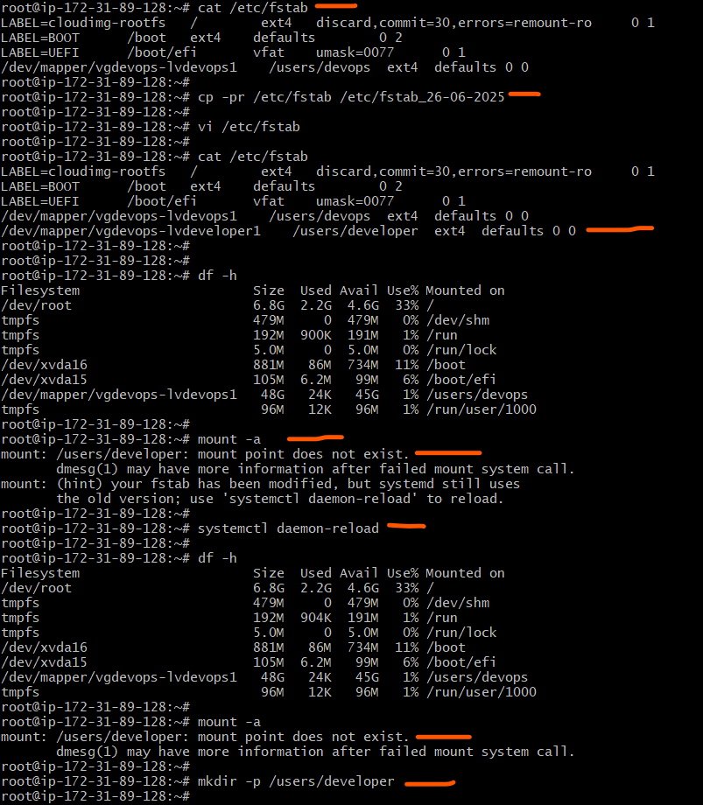

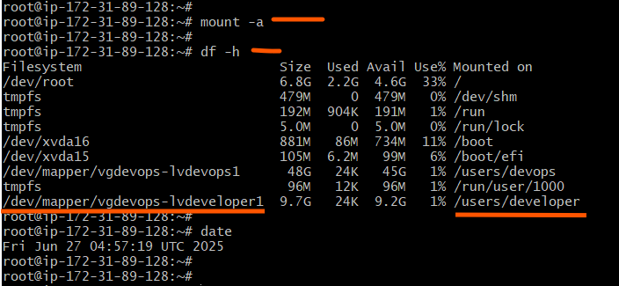

* Create a new disk and attach it to server, create a Physical volume on the complete disk.

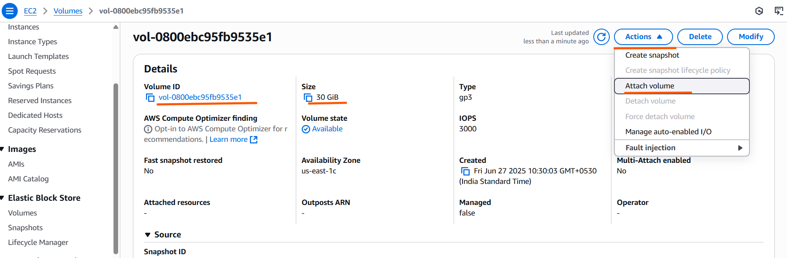

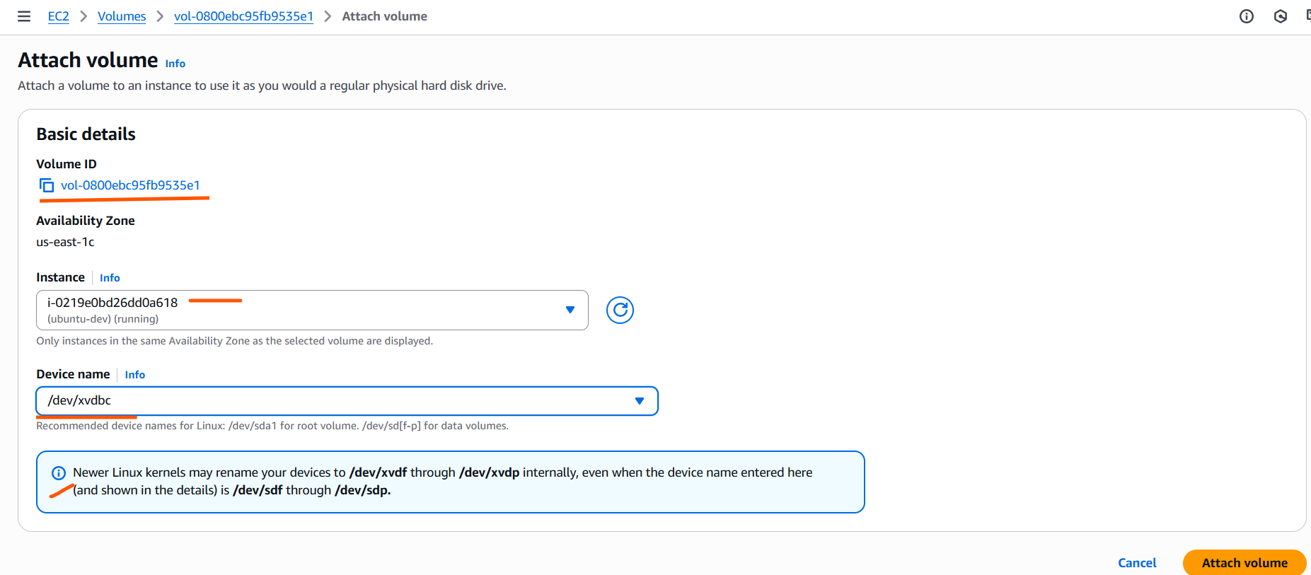

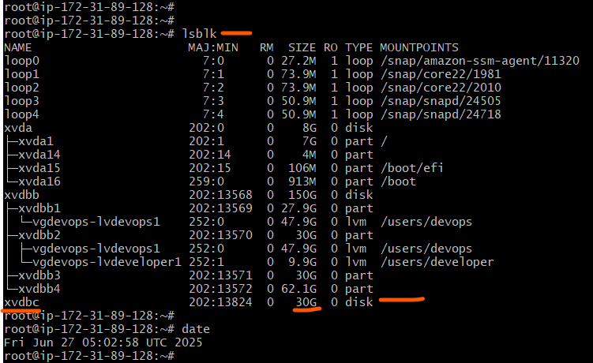

* Create a dedicated Volume group with new physical volume created on the entire drive.
* Create file system and mount as persistent.

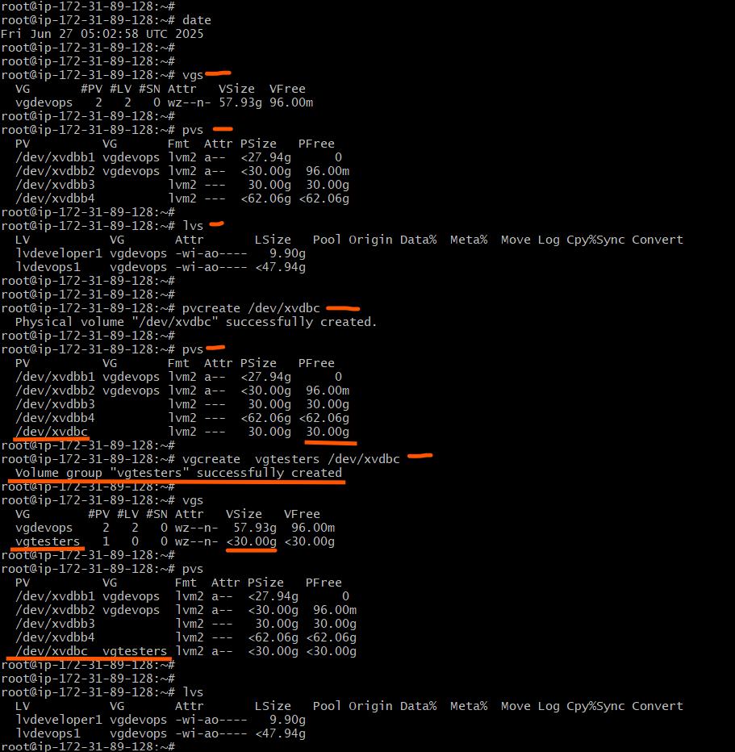

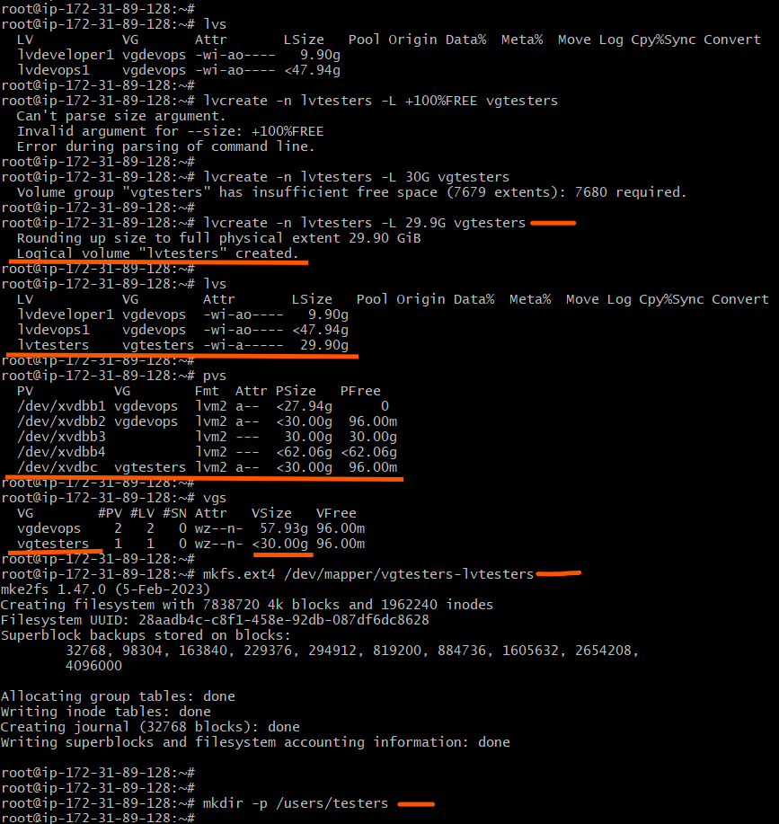

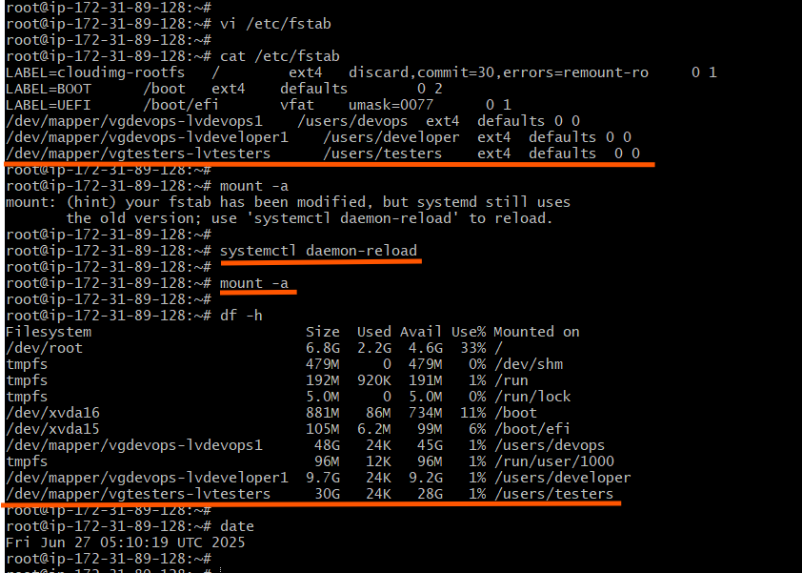

* Extend the newly created dedicated physical volume by 10GB

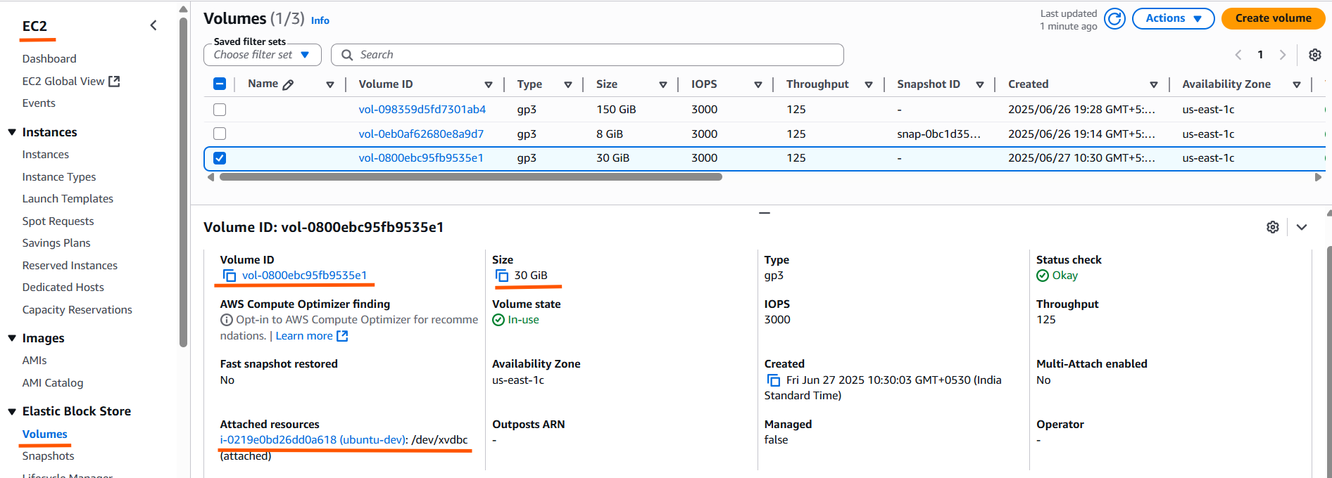

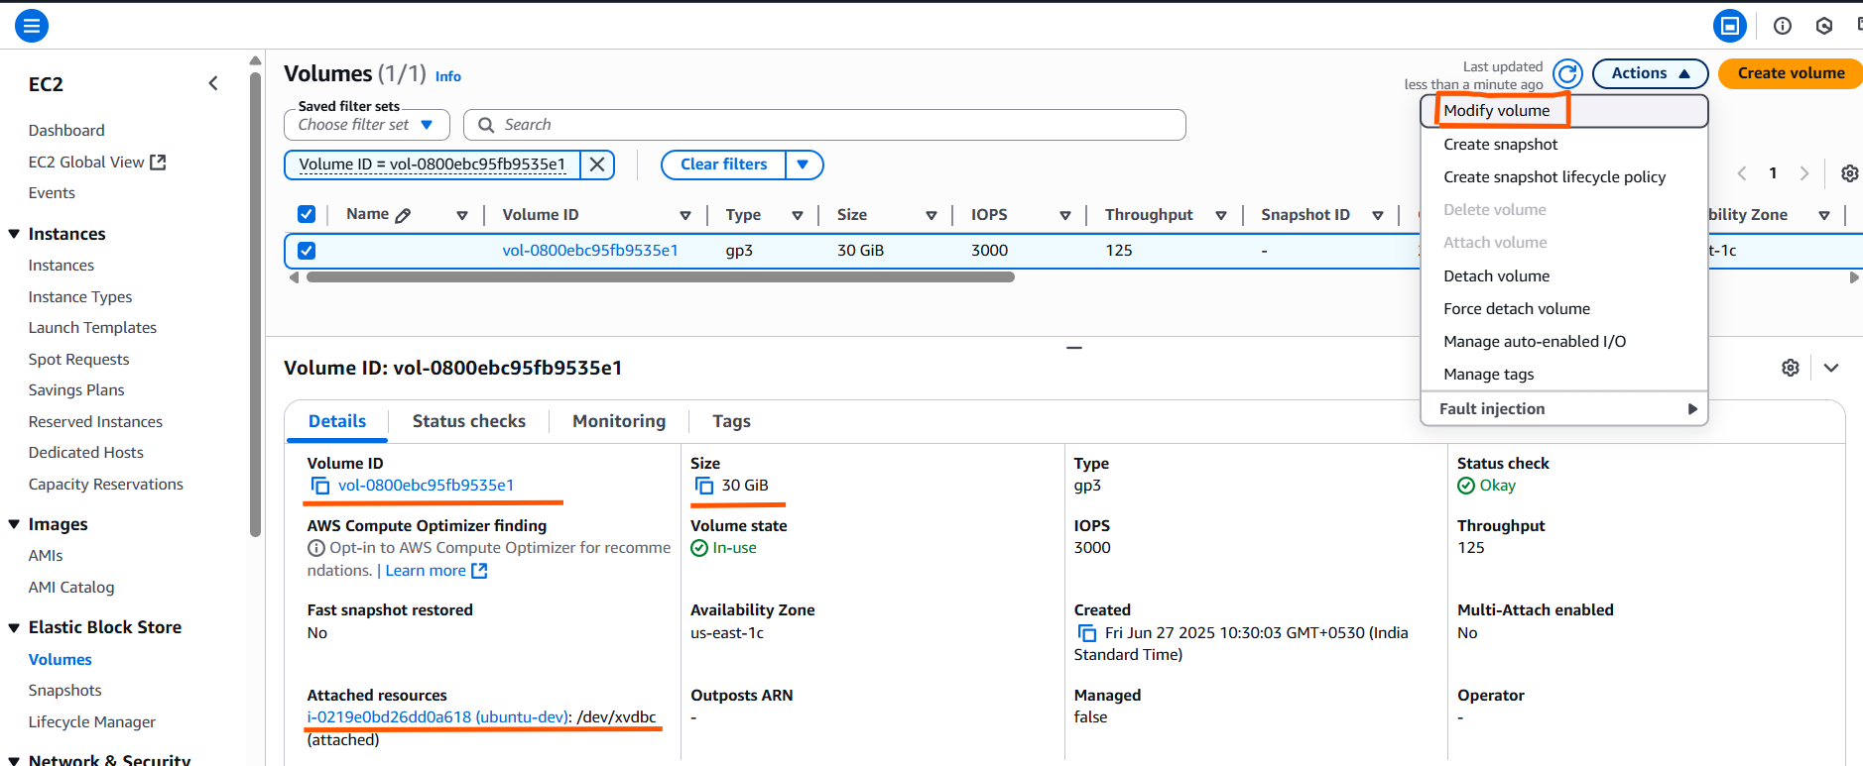

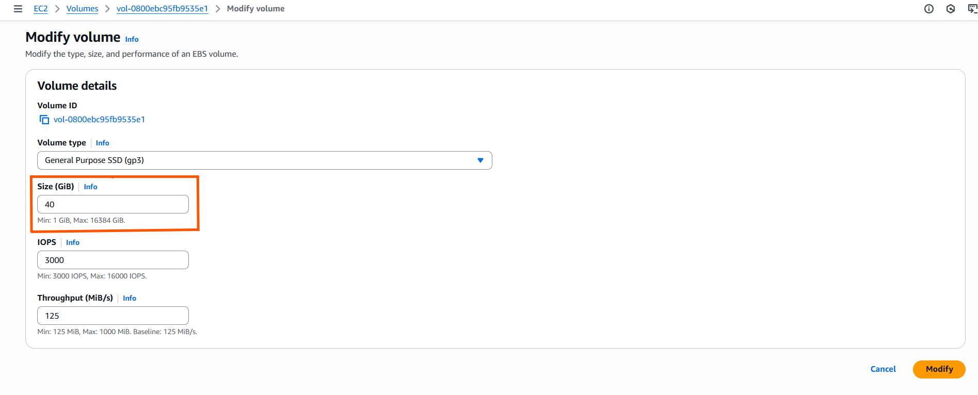

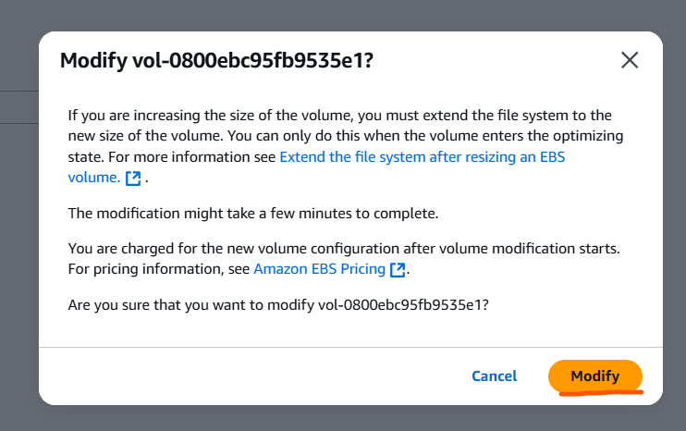

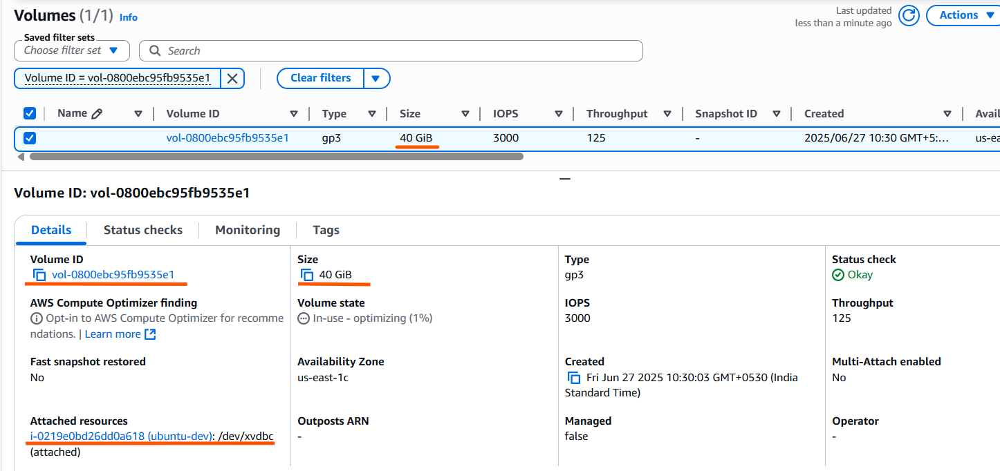

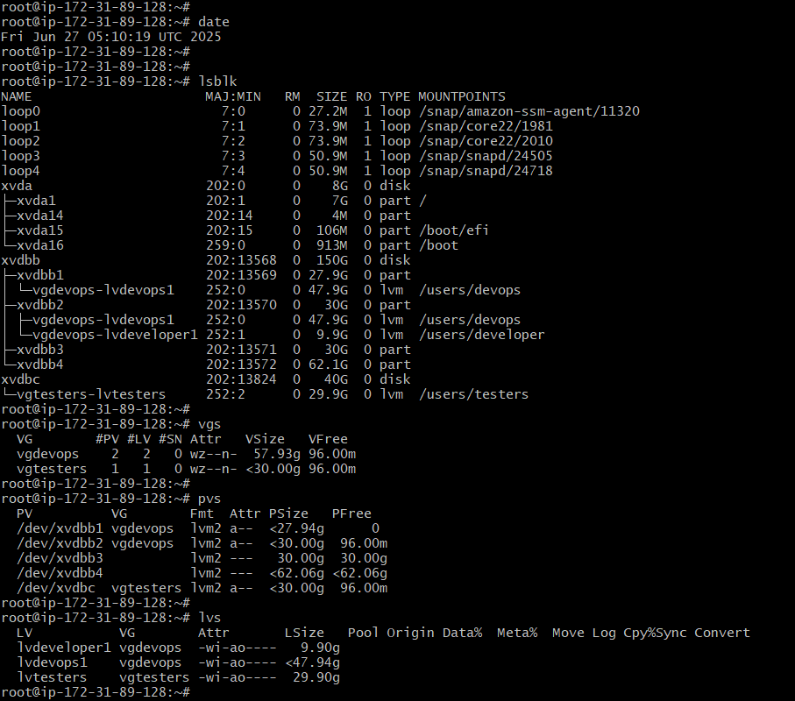

* Resize the physical volume.
* Extend the lvm and resize filesystem

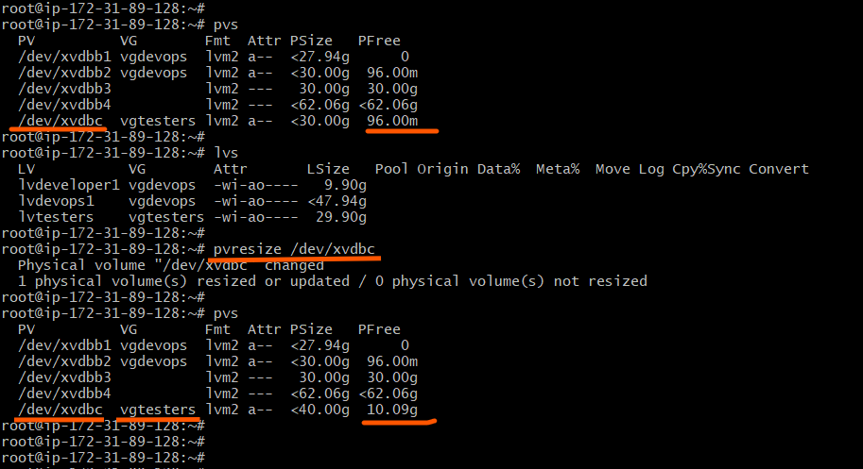

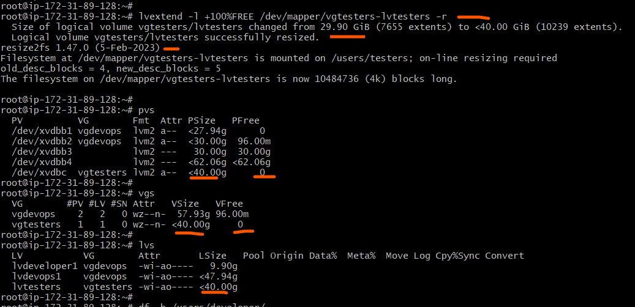

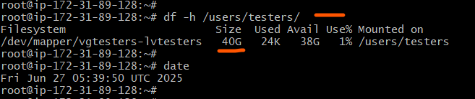

Filesystem space reclaims and makes drives empty and detach from server.

Unmount filesystems

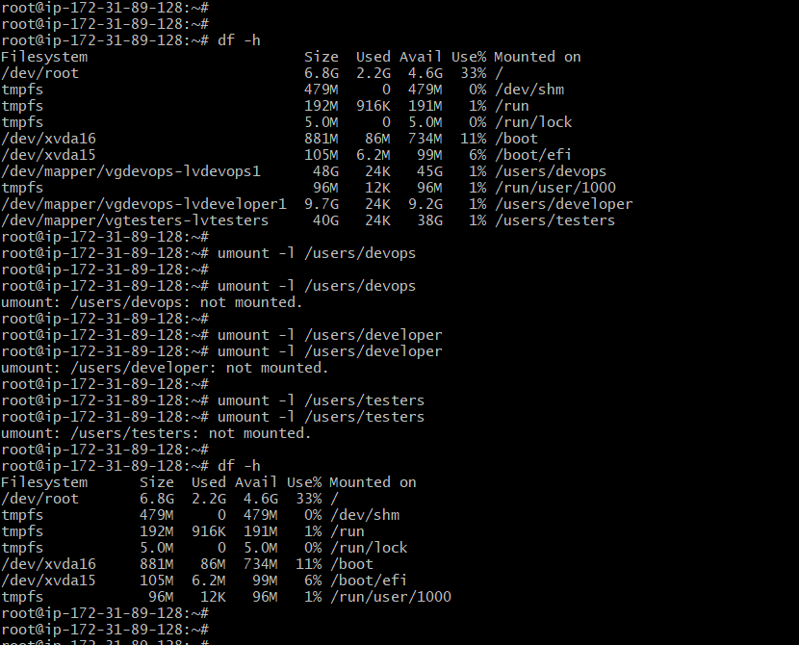

Remove Logical volumes

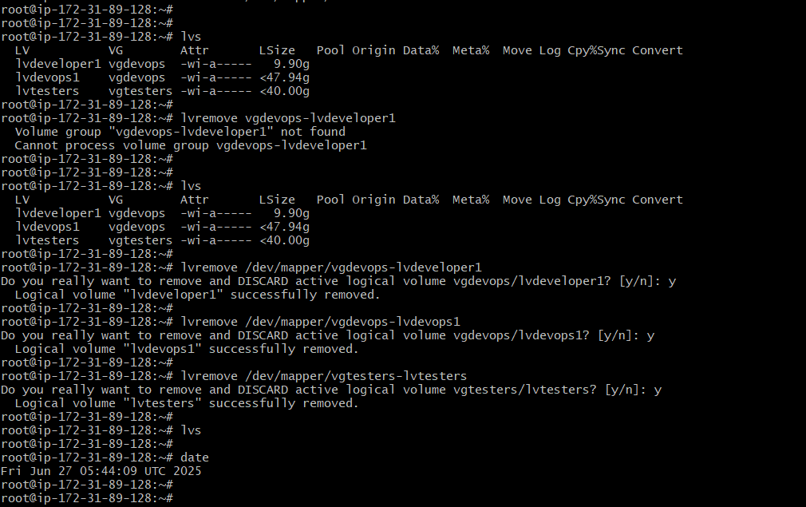

Remove physical volumes from Volume groups and remove Volume groups

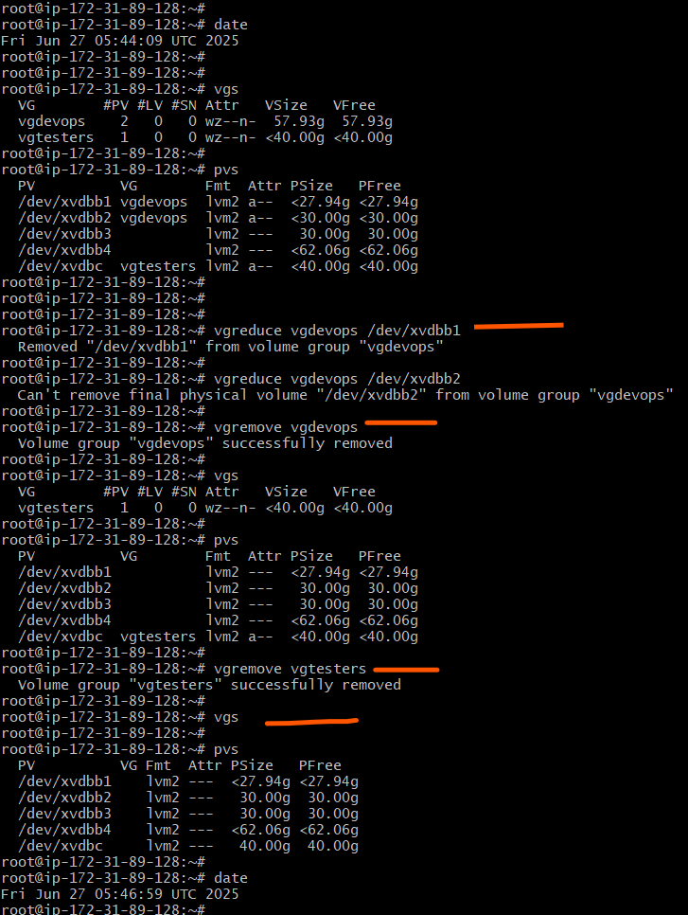

Remove Physical volumes.

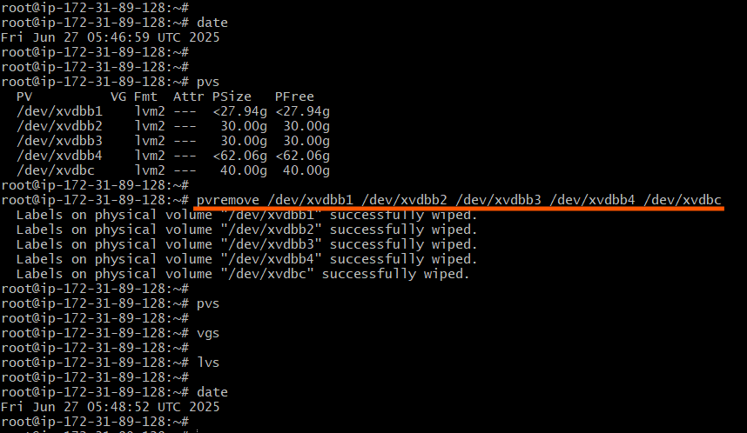

Delete partitions from disks /dev/xvdbb and /dev/xvdbc

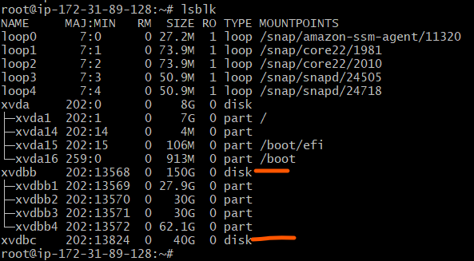

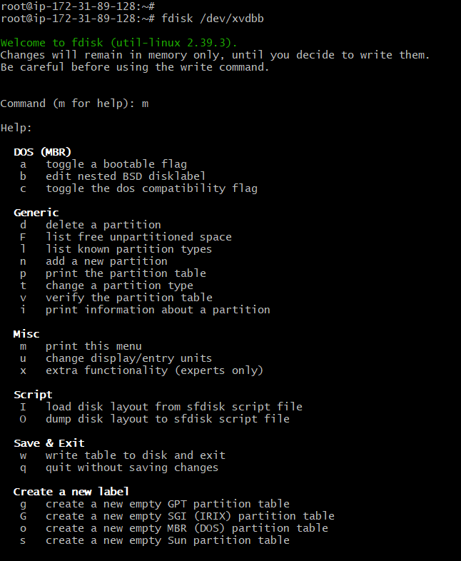

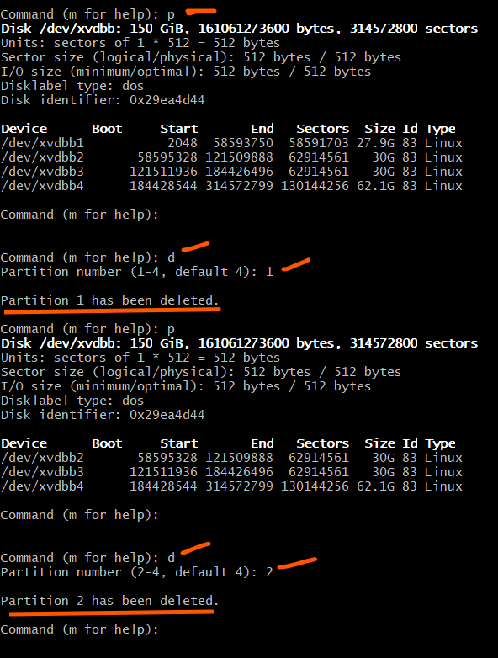

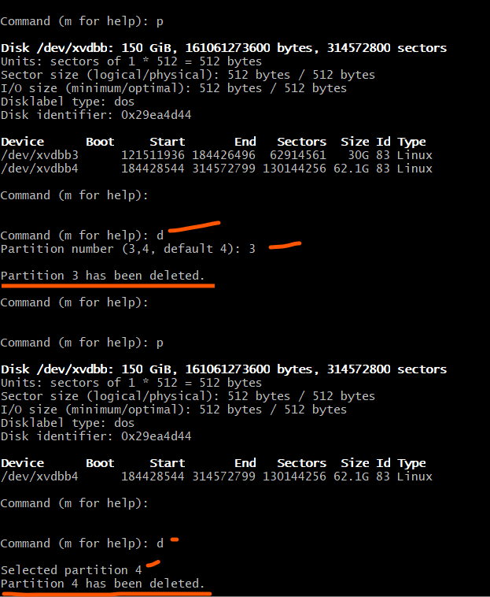

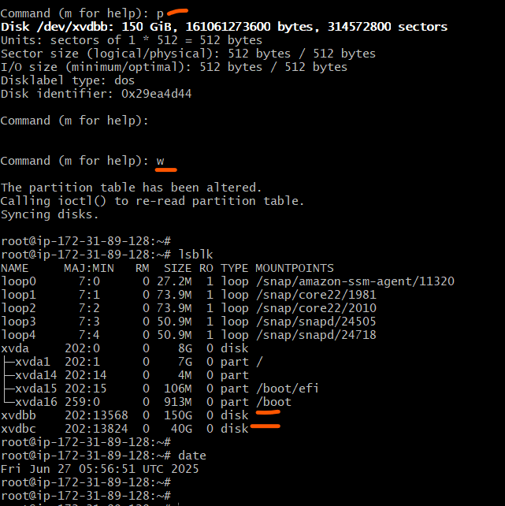

Detach /dev/xvdbb and /dev/xvdbc from Ec2 instance

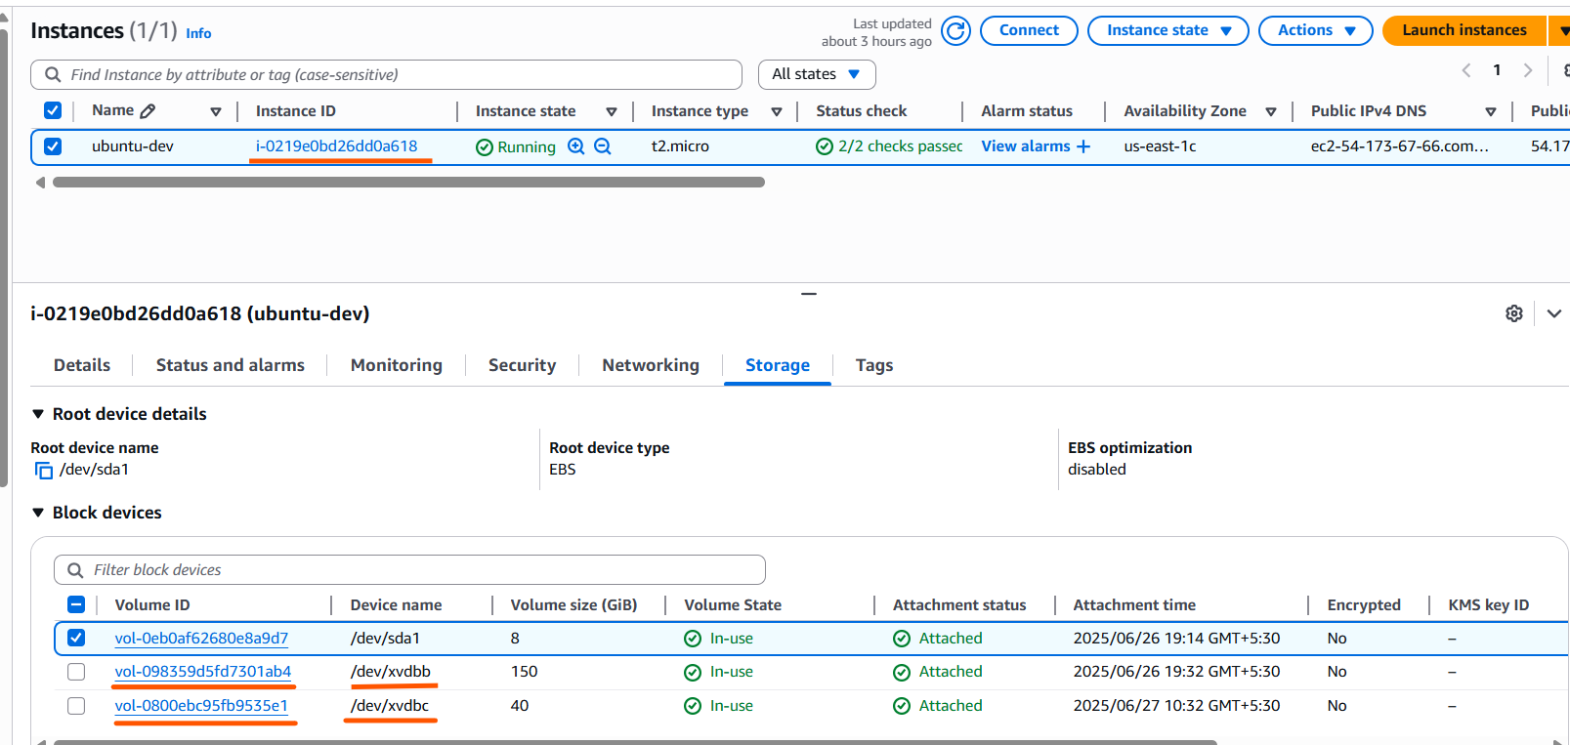

| **Volume ID** | **Device name** | **Volume size (GiB)** |
| --- | --- | --- |
| [**vol-098359d5fd7301ab4**](https://us-east-1.console.aws.amazon.com/ec2/home?region=us-east-1#Volumes:volumeId=vol-098359d5fd7301ab4;sort=desc:createTime) | **/dev/xvdbb** | **150** |
| [**vol-0800ebc95fb9535e1**](https://us-east-1.console.aws.amazon.com/ec2/home?region=us-east-1#Volumes:volumeId=vol-0800ebc95fb9535e1;sort=desc:createTime) | **/dev/xvdbc** | **40** |

